**Format of the URL to get the specific applicable refiners and filtered by source is as follows**

http://**SITE**/_api/search/query?querytext=’**TEXT**’&refiners='[**REFINERS**]'& sourceid=’**GUID**’&QueryTemplatePropertiesUrl='spfile://webroot/queryparametertemplate.xml'

**SITE:** Domain of the site

**TEXT**: query text

**REFINERS**: refiner’s names with comma separated (defined in the backend)

**GUID**: GUID of source ID

**For example, following query returns the refiner values of product, release, language for support source in stage**

http://**search-stage.ca.com**/_api/search/query?querytext='**\***'&refiners=**'products,ProductVersions,Language**'&sourceid=**'835d7d71-c7fd-4a0d-aa82-d6aa489a0985**'&QueryTemplatePropertiesUrl='spfile://webroot/queryparametertemplate.xml'

The JSON entries to look for the refiners is as highlighted in the below screen shot

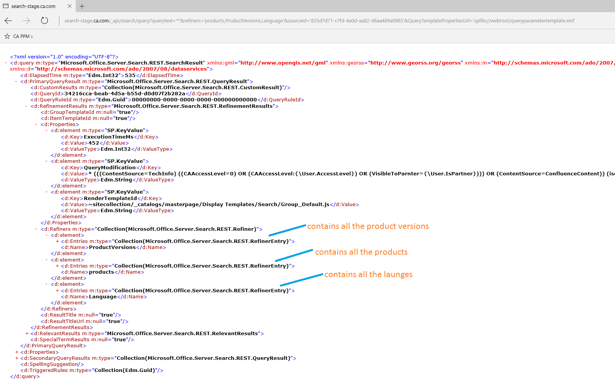

The expanded view would be as below and the elements d:RefinementValue will contain the value we are looking for i.e product name as in below .

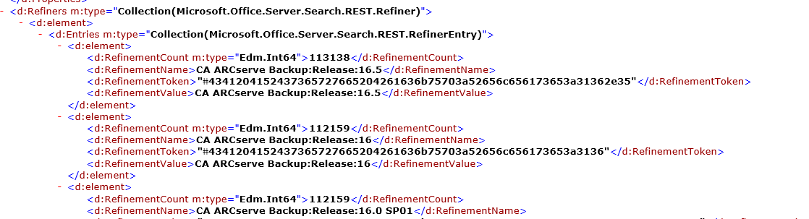

**Issue:**

Release name are in the format

**<<productname>>:Release:<<** **Release name >>**.

we need to split this to get Release name.

As mentioned the in the call there are some release names for which we do not have the mapping product information for example as highlight below.

